SMART EVENT TICKETING AND VERIFICATION SYSTEM

By
Candidate Number: 0625002G00026

Full Name: Shantel Mbonwapi

Submitted in partial fulfilment of the requirements of the
(HEXCO)

NATIONAL DIPLOMA IN INFORMATION TECHNOLOGY

INFORMATION SCIENCE AND TECHNOLOGY DEPARTMENT

at

Bulawayo Polytechnic

BULAWAYO
Matebeleland North Region

November 2026

Supervisor: Mrs. S Mutukwana

DECLARATION
I, Shantel Mbonwapi hereby declare that I am the sole author of this project. I authorize Bulawayo Polytechnic to lend this software development project to other institutions or individuals for the purpose of scholarly research.

Signature_________________________________ Date_____________________________

APPROVAL
This project, entitled “SMART EVENT TICKETING & VERIFICATION SYSTEM” by Shantel Mbonwapi meets the regulations governing the award of the National Diploma in Information Technology by Higher Examinations Council (HEXCO), and is approved for its contribution to knowledge and literary presentation.

Supervisor’s Signature:_____________________________ Date :____________________

ABSTRACT
The Smart Event Ticketing & Verification System is a web-based platform designed to streamline event ticketing by automating ticket purchase, validation, and attendance tracking using QR code technology. The system addresses challenges in traditional paper-based ticketing, including fraudulent tickets, long queues, and difficulty monitoring attendance. Attendees can securely purchase tickets online (payment is simulated in the current version) and receive unique QR codes for seamless entry, while event organizers can manage events, monitor real-time attendance, and generate automated reports for revenue and planning purposes. Developed using PHP, MySQL, and the Laravel framework, the system provides a secure, efficient, and cost-effective solution that enhances user experience, improves operational efficiency, and ensures accurate control over ticketing processes.

ACKNOWLEDGEMENT
I would like to express my sincere gratitude to all those who contributed to the successful completion of this project. I am especially thankful to my supervisor for their guidance, support, and valuable advice throughout the research and development process. I also extend my appreciation to the event organizers and attendees who provided insights and feedback during the fact-finding stages. Finally, I acknowledge my family and friends for their encouragement and moral support, which motivated me to complete this project successfully.

DEDICATION
I dedicate this project to my family and friends for their unwavering support, encouragement, and inspiration throughout my academic journey. Their guidance and belief in my abilities have been instrumental in the successful completion of this work.

TABLE OF CONTENTS
DECLARATION i
APPROVAL ii
ABSTRACT iii
ACKNOWLEDGEMENT iv
DEDICATION v
ABBREVIATIONS/ACRONYMS ix
GLOSSARY x
LIST OF FIGURES xi
LIST OF TABLES xii
CHAPTER ONE: PROJECT IDENTIFICATION 1
1.1 INTRODUCTION 1
1.2 PROBLEM DEFINITION 1
1.3 OBJECTIVES OF THE PROPOSED SYSTEM 2
1.4 JUSTIFICATION 2
1.5 DEVELOPMENT TOOLS 3
1.6 CONCLUSION 3
CHAPTER TWO: FEASIBILITY ANALYSIS 4
2.1 INTRODUCTION 4
2.2.2 FEASIBILITY ANALYSIS 4
2.2.1. TECHINICAL FEASIBILITY: 5
2.2.2 OPERATIONAL FEASIBILITY 8
2.2.3 SCHEDULE FEASIBILITY 8
2.2.4 ECONOMIC FEASIBILITY 9
2.2 CONCLUSION 12
CHAPTER 3: RESEARCH PHILOSOPHY AND METHODOLOGY 13
3.1 Introduction 13
3.2 Fact Gathering Techniques 13
3.2.1 Questionnaires 13
3.2.2 Interviews 14
3.2.3 Observations 15
3.2.4 Data Analysis 15
3.2.5 Activity Diagram 16
3.3 User Requirements 17
3.3.1 Functional Requirements 17
3.3.2 Non-Functional Requirements 17
3.4 Hardware Requirements 18
3.5 Software Requirements 19
3.6 System Models 19
3.6.1 Data Flow Diagram (DFD) / UML 19
3.6.3 Entity Relationship Diagram (ERD) / Class Diagram 22
3.6.4 Data Dictionary 22
3.7 Conclusion 23
CHAPTER 4: SYSTEM DESIGN 24
4.1 Introduction 24
4.2 Design Methodology 24
4.3 Physical Design 24
4.4 Input Design 25
4.5 Process Design 26
4.5.1 Data Flow Diagrams (DFD) / UML 26
4.5.2 Flowcharts 27
4.5.3 Pseudocode / Structured English 29
4.6 Output Design 29
4.7 Dialogue Design 31
4.8 Control and Security Design 32
4.8.1 Input Controls 33
4.8.2 Process Controls 34
4.8.3 Output Controls 35
4.8.4 Database Controls 35
4.8.5 Physical Security 35
4.8.6 Logical Security 35
4.9 Database Design 36
4.9.1 Database Model Used 36
4.9.2 Database Tables 36
4.9.3 Normalization 38
4.9.4 Data Dictionary 38
4.9.5 Entity Relationship Diagram (ERD) 39
4.10 Conclusion 39
CHAPTER 5: CODING 40
Routes 40
Login 45
Register 48
Logout 50
Update Event 50
Scan View 52
CHAPTER 6: IMPLEMENTATION 55
6.1 Introduction 55
6.2 System Testing 55
6.2.1 Testing Procedures (Verification and Validation) 55
6.2.2 Testing Process (Methodologies) 55
6.2.3 Test Data 56
6.2.4 Test Results 56
6.3 System Conversion 56
6.4 User Training 57
6.5 System Evaluation 57
6.5.1 Strengths 57
6.5.2 Weaknesses 57
6.5.3 Future Plans 58
6.6 Conclusion 58
CHAPTER 7: FUTURE PLANS 59
7.1 System Enhancements 59
7.2 Security Enhancements 61
7.3 User Training and Support 62
7.4 Regular User Feedback Sessions 63
7.5 Long-Term Vision 63
7.6 Conclusion 64
REFERENCES ix
APPENDIX A: INTERVIEW GUIDE x
APPENDIX B: QUESTIONNAIRE xi
APPENDIX C: OBSERVATION GUIDE xii

ABBREVIATIONS/ACRONYMS
Abbreviation / Acronym | Full Form | Description
QR | Quick Response | A type of barcode used for fast ticket validation.
PHP | Hypertext Preprocessor | Server-side scripting language used for system development.
MySQL | My Structured Query Language | Database management system for storing ticket and user data.
HTML | Hypertext Markup Language | Standard markup language for creating web pages.
CSS | Cascading Style Sheets | Styling language used to design the front-end of the system.
JS | JavaScript | Programming language used for front-end interactivity.
UML | Unified Modeling Language | Standard way to visualize system design and processes.
DFD | Data Flow Diagram | Diagram that shows the flow of data within the system.
ERD | Entity Relationship Diagram | Diagram showing relationships between database entities.
ROI | Return on Investment | Financial measure to assess profitability of the system.
API | Application Programming Interface | Interface used to generate and scan QR codes.

GLOSSARY
Term | Definition
QR Code | A machine-readable code consisting of black squares arranged on a white background, used to store ticket information for quick scanning and verification.
Ticket Fraud | The act of creating, duplicating, or selling invalid tickets to gain unauthorized access to an event.
Validation | The process of confirming the authenticity and validity of a ticket before granting entry.
Online Ticketing | A digital method for purchasing tickets via a web-based platform instead of physical counters.
Real-Time Monitoring | The ability to track ticket usage and attendance instantly as events occur.
System Conversion | The process of transferring from a manual or old system to the new automated ticketing system.
Front-End | The part of the system that interacts directly with users, including forms, dashboards, and navigation.
Back-End | The server-side of the system where data processing, ticket generation, and database management occur.
Functional Requirements | Specific features and functions that the system must provide, such as ticket generation and scanning.
Non-Functional Requirements | Attributes that define system performance, security, usability, and reliability, rather than specific behaviours.

LIST OF FIGURES
Figure 1: Activity Diagram 16
Figure 2: Level 0 DFD 20
Figure 3: Flowchart 21
Figure 4: ERD 22
Figure 5: Input Design 1 25
Figure 6: Input Design 2 26
Figure 7: Level1 DFD 27
Figure 8: ticket purchase flowchart 28
Figure 9: Output design 1 30
Figure 10: Output design 2 30
Figure 11: Output design 3 31
Figure 12: Dialogue design 32
Figure 13: Control and Security Design 32
Figure 14: Input Controls1 33
Figure 15: Input Controls2 34
Figure 16: Process Controls 34
Figure 17: Output Controls 35
Figure 18: Logical Security 36
Figure 19: ERD 39
Figure 20: User Dashboard 60
Figure 21: Event Organizer Dashboard 61
Figure 22: Administrator Dashboard 62

LIST OF TABLES
Table 1: Hardware requirements 7
Table 2: Software requirements 7
Table 3: Gantt chart 9
Table 4: COST BENEFIT ANALYSIS 10
Table 5: Hardware Requirements 18
Table 6: Software Requirements 19
Table 7: Data Dictionary 22
Table 8: Database categories 36
Table 9: Database Events 37
Table 10: Database Tickets 37
Table 11: Database Transactions 38
Table 12: Database Users 38
Table 13: Data Dictionary 39
Table 14: Troubleshooting guide 63

CHAPTER ONE: PROJECT IDENTIFICATION

1.1 INTRODUCTION
This chapter provides an overview of the proposed system, including the problem definition, objectives, and development tools. The current manual or traditional ticketing processes have led to fraudulent ticket sales, long queues, and difficulty in tracking attendance. The proposed system will automate ticket purchasing, validation, and verification using QR code technology, allowing event organizers and attendees to experience seamless event management.

1.2 PROBLEM DEFINITION
According to modern event management research, ticket fraud and inefficient entry management are major challenges affecting event organizers. This section highlights the existing problems:
- Ticket Fraud – Counterfeit and duplicated tickets lead to revenue loss.
- Long Queues at Entry Points – Manual verification causes delays and congestion.
- Difficulty in Tracking Attendance – Lack of a real-time system results in poor event planning.
- Unauthorized Ticket Reselling – Tickets are resold illegally without organizer control.
- Limited Customer Engagement – No efficient method to update attendees on event details.
- Paper-Based Ticketing Hassles – Printed tickets can be lost or damaged.

The proposed Smart Event Ticketing and Verification System will eliminate these challenges through automated ticket generation, QR-based validation, and real-time monitoring.

1.3 OBJECTIVES OF THE PROPOSED SYSTEM
The system aims to achieve the following:
- Generate QR Code-Based Digital Tickets – Assign unique QR codes to tickets upon purchase.
- Develop an Online Ticket Purchase System – Enable users to buy tickets via a secure web portal.
- Create a Real-Time Ticket Validation System – Allow event staff to scan and verify tickets at entry points.
- Prevent Fraud and Unauthorized Reselling – Ensure each ticket is scanned only once per entry.
- Provide a Dashboard for Event Organizers – Manage ticket sales, attendee lists, and revenue reports.
- Generate Automated Reports for Event Organizers – Provide analytics on ticket sales, attendee check-ins, and revenue generation.

1.4 JUSTIFICATION
Implementing a QR-based ticketing system will:
- Prevent Fraud – Unique QR codes make duplication impossible.
- Reduce Check-In Time – QR scanning speeds up entry, reducing long queues.
- Increase Revenue Control – Prevents unauthorized ticket reselling.
- Improve Event Planning – Real-time attendance tracking assists organizers.
- Enhance User Experience – Provides digital convenience over paper tickets.
- Reduce Costs – Eliminates printing costs and manual verification efforts.
With the increasing demand for digital transformation in event management, this system provides a secure, efficient, and seamless ticketing experience.

1.5 DEVELOPMENT TOOLS
The following tools will be used for system development:
- PHP – Server-side scripting language for handling ticket generation and validation.
- MySQL – Database management system to store ticket and attendee details.
- HTML, CSS, JavaScript – For front-end development and user interface design.
- Laravel Framework – To build a structured and secure web-based system.
- XAMPP Server – To host and test the web application during development.
- Google Chrome – Web browser for testing user interactions.
- QR Code API (e.g., PHP QR Code Library) – For generating and scanning QR codes.

1.6 CONCLUSION
In conclusion, this proposal outlines the need for a QR-based event ticketing system to eliminate fraud, improve efficiency, and enhance event management. The objectives, problem statement, and system justification have been clearly defined. By using modern web technologies, the system will provide real-time ticket tracking, faster event check-ins, and better attendee management. This project will bring significant improvements to the event industry, offering a cost-effective and scalable solution for secure ticketing and validation.

CHAPTER TWO: FEASIBILITY ANALYSIS

2.1 INTRODUCTION
The awareness of the project to all project members was made possible by the previous chapter. This stage focuses on the activities that will be carried out as well as the timeline for the project's progress. Evaluation and assessment of the business case is done at this phase. According to Bruce and Langdon (2017), to commence a project it is necessary to take precautionary steps which include analyzing the feasibility to guarantee the success of the project. Feasibility study is an economic analysis that is carried out to ascertain the ability of the final product to satisfy the objectives of the investor. A feasibility analysis is being done to confirm if the proposed system meets the organization’s objectives. It also analyses if the system will produce with the budgeted technologies available. It also analyses the implementation of the proposed system to see if its processes will not affect the existing systems. Simpson et al (2014) argue that the following are the main aspects of the feasibility study.

2.2 FEASIBILITY ANALYSIS
This refers to the practical analysis which is carried out by the management or even the project team to fully understand the needs and requirements of a particular idea or project to come up with a risk assessment plan (Shelly and Rosenblatt, (2017)), which helps in considering if this is applicable or not. Such a study attempts to show whether the project can be designed within a specific set of targets as well as set time constraints. If the project meets the set constraints it is, however, considered an acceptable one since it proves to outweigh the shortcomings expected from its failure. Therefore, feasibility comes to outline if the project system should be created or implemented, measure if the objectives set for the system can be achieved within the organizational current monetary, political, administrative, commercial and technical states (Rosenblatt, (2014)). However, such things will outline why the proposed system should be seen as a helpful tool to help the institution in upgrading and improving the business’ IT structures and be in line with environmental needs and changes
- Possibilities concerning the practical aspects of the proposed system (Is this going to run smoothly?)
- Possibilities of the system fully working in the intended environment (What kind of changes will be noted in the current available working environment and its operations as well as which ones become advanced?)
- Financial constraints (is it going to be financially manageable or not?)

Types of Feasibility

2.3 TECHINICAL FEASIBILITY:

At this stage the team and the organization management seat together and analyze if the listed system requirements match perfectly with the available structures or resources. Thus the two may consider the following aspects:
- Are the listed technological requirements available within the organization
- Are the extra needs for development currently available for exploitation such as the programming experts, design and other systems gurus

Rosenblatt (2014) defined technical feasibility as the need for technical resources to accommodate the development, purchasing installation and operating the proposed system. So, as the software and hardware issues are solved and all made compatible to each other as needed by the project owner, showing that there is a well-established level of technical feasibility. Then this leaves room to consider the financial aspects which are as important as other factors that leads to the rejection or acceptance of a particular project. Since the world is slowly growing digital, many people have no problem adapting to any system changes and new technologies because there is a considerable level of computer literacy as IT technologies dominate all-round the globe. This will reduce the costs associated with training the stakeholders associated with the system. As soon as the hardware and software are configured to meet requirements proclaimed by the proposed system and establish a well-organized technical possibility, it is, however, necessary to take into consideration the financial factors which significantly make a project acceptable and feasible. However, apart from the high level of computer literacy, there is little concern needed to train the people going to use the system on how to use it after its existence. Therefore, on such terms the system development, however, made it easier as users specify some of their needs before system introduction.

- Project size
As on this phase, the project’s size looks big and a bit complex in nature since most of the objectives need proper coding skills and good development strategies. Interface designs are going to be made or created using HTML and PHP based structures so that the interfaces are functional and attractive for both the internal and external users within the institution scope. As for databases, they will be created using either MYSQL or Microsoft SQL since either of the two support OLAP.
The technical feasibility checks show the existence and capabilities of both the system’s hardware and software requirements within the institute. Therefore, there will be less costs since most of the requirements are readily available, the only thing needed to do is to separate one of the computer servers to support backups for the system. The organization already has state of the art kind of hardware specs which will support the system implementations around the network for exploitation during research. The network being referred to be either the local network linked through cables which facilitates Server/client kind of structure or set up or access through the internet networks. As is known in all organizations, the IT division is home to many legalized computer systems which are necessary for systems development and project viability. Therefore, the shortage of skilled and very committed programmers is the only noticeable shortfall on all the necessary needs, but it will not be considered as a drawback to the system development process.

- Hardware requirements
Table 1: Hardware requirements
Item | Specification | Quantity | Available |  | Comment
Server | Ram 8.00GB , Intel 3.2 GHz processor, 500 gig hard drive | 1 | No | The organization is willing to buy
Internet Router | 2mbs and above | 1 | Yes | The organization already has internet access
Network Cables | LAN cable (2 meters) | 2 | Yes | The organization already has internet access
Printer | HP LaserJet Pro P1108 Printer(CE655A) | 1 | No | The organization is willing to buy
Laptop | Core i5, 4GB RAM, 500GB HDD and above | 1 | Yes | The organization already has a working laptop.
Table 2: Software requirements
Item | Specification | Quantity | Available
Operating System | Windows 10 and above | 1 | Yes
Text Editor | Visual Studio Code | 1 | Yes
Local Host | XAMPP | 1 | Yes
Browser | Mozilla Firefox, Google Chrome | 1 | Yes

Overview of technical feasibility
The project is technically feasible since the resources are available and additional resources readily available on the market for system development.

2.4 OPERATIONAL FEASIBILITY
Bentley et al (2016) view operational feasibility as an assessment of how the system operates to tackle the challenges and its fitness to the business environment and the business processes as well. Operational feasibility measures how well a proposed system eliminates an identified problem, and exploits identified opportunities in scope defining how it fulfills the prerequisites distinguished during the requirements analysis of the system development phase. The focus of operational feasibility is on issues which incorporate the proposed system utilization once there is successful implementation (Rosenblatt 2014). It is of best interest to take a glance at the helpfulness of the recently proposed system mirrored against the present working framework to have the capacity to completely welcome the new framework's attainability as far as its operational efficiency is concerned (Rodger, 2015).
- The proposed system is web based, and the clients will access the system using their mobile devices.
- There is better communication and clarity when clients lodge their complaints.

2.5 SCHEDULE FEASIBILITY
It is the degree to which a deadline for a strategy, plan, project or process is realistic and achievable. A scheduled feasibility study will consider the period in which the project is going to take up to its completion. A project will fail if it takes too long to be completed before it is useful. Typically, this means estimating how long the system will take to develop and if it can be completed each time using some method like payback period. Schedule feasibility is a measure of how reasonable the project timetable is. Given our technical expertise, are the project deadlines viable? Some projects are initiated with specific deadlines. It is necessary to determine whether the deadlines are mandatory or desirable.
2.3.1 WORK PLAN
Wang and Wang (2012) defined the project work plan as activity calendar which accounts and keeps track of all actions that need to be carried out over the course of the project.

2.3.2 Gantt chart
Milosevic (2013) defined a Gantt chart as a horizontal bar which illustrates time and on its vertical axis it shows the list activities to be done in the project.
Table 3: Gantt chart
Phases(Weeks) | 1 | 2 | 3 | 4 | 5 | 6 | 7 | 8 | 9 | 10 | 11 | 12
Proposal
Planning
Analysis
Design
Coding
Implementation
Documentation
Maintenance

KEY : one week

2.6 ECONOMIC FEASIBILITY
Basically, when certain software is being analyzed, the team expect to design something that will produce more benefit than costs while being efficiently functional. If the benefit exceeds the amount of expenditure in any level, this will allow investors and management to accept the proposed system implementation. Techniques such cost benefit analyses are adopted to calculate the measurable return and expected costs. Economic feasibility is however, done to see if the system is fundable and economically feasible and this has been supported by (Shelly and Rosenblatt, (2014)). This feasibility study is important to come up with the cost to be incurred and the benefit or return expected from the use of the system. All this will be achieved through cost benefit analysis techniques.
Running expenses refers to those negative charges incurred while the system is functioning and running daily.
Implementation Costs: refers to those costs which are incurred initially during the development of the whole system that is costs attached to very stage in the development stage and these are one-time costs (Investment costs).
2.4.1 COST BENEFIT ANALYSIS
Coming up with a computer-based system is often challenging and considered as a venture which produces high returns if designed well to the institute or organization. Weingadt, Kimmel and Kieso (2018), stated that cost benefit analysis is a way of identifying the costs and benefits of engaging in a certain investment after analysis and evaluations have been undertaken Cost benefit analysis technique helps the decisions makers on making decisions such as the prediction of risk to be involved as well as the rate of income if successfully implemented.
Table 4: COST BENEFIT ANALYSIS
YEARS | 2025 | 2026 | 2027
0 | USD | USD | USD
Value addition on service | 1800 | 2000 | 2200
Efficiency increment | 1200 | 1500 | 1800
Security maintenance | 800 | 800 | 800
Stationery reduction | 200 | 200 | 200
Sum of benefit | 4000 | 4500 | 5000
Developmental costs
Technical labor | 700 | 0 | 0
Licensed software | 600 | 0 | 0
Software components (additional) | 1800 | 0 | 0
Training expense | 400 | 0 | 0
Developmental Cost (sum) | 3500 | 0 | 0
Operational Expenditure
Maintenance and repairs | 500 | 500 | 500
Stationery | 300 | 350 | 400
Additional costs | 400 | 450 | 500
Total | 1200 | 1300 | 1400
Total costs | 4700 | 1300 | 1400
Total benefits | 4000 | 4500 | 5000
Profit/ Loss | (700) | 3200 | 3600

Net profit
This is the actual return or profit gained after all costs and gross profit have been paid (Randall,2018))
Total benefits-Total Costs
=(4000+4500+5000)-(4700+1300+1400)
=13500 – 7400
=6100
Return on Investment
Refers to the measure of perform calculated to see how much return is being recognized in an investment (Randall, (2018)).
R.O.I = (average total profit (annual) / Investment (total) ) * 100%
Average Annual Profit = 6100 / 3 = 2033.33
= (2033.33 / 3500) * 100%
= 58.1%
Net Profit: $6,100
Average Annual Profit: $2033.33
ROI: 58.1%

2.7 CONCLUSION
This chapter focused on:
Comparison between the proposed and current system
- The level at which the organization will find some academic problems through user satisfaction analysis and system confidence.
- The amount of return and costs to be consumed during project implementation as well as its development time durations.
- The availability of technical tools and technical specialists, system technical requirements as well as its technical forecasts.
Therefore, the next stage that comes after the planning stage aims to analyze the systems currently running within the institute for users and understand how it functions and tackles problems. Hence attention now may be directed to the proposed platform to fully plan and encourage its deployment around the institution.

CHAPTER 3: RESEARCH PHILOSOPHY AND METHODOLOGY

3.1 Introduction
Research methodology refers to the overall strategy used to integrate the different components of a study in a coherent and logical way to effectively address the research problem. According to Saunders, Lewis, and Thornhill (2019), methodology provides a framework for data collection, analysis, and interpretation. In this project, the methodology outlines the approaches taken to gather data, understand user needs, and design the Smart Event Ticketing and Verification System. The chapter also highlights fact-gathering techniques, user requirements, system models, and tools required for development.

3.2 Fact Gathering Techniques
Fact gathering techniques are systematic approaches used to collect relevant information for system design and development. Creswell and Creswell (2020) state that appropriate data collection methods improve the reliability and validity of system requirements. For this study, questionnaires, interviews, and observations were applied to ensure a comprehensive understanding of the ticketing challenges and expectations from both organizers and attendees.

3.2.1 Questionnaires
A questionnaire is a structured set of questions designed to collect quantifiable data from many respondents (Sekaran & Bougie, 2020). Questionnaires were distributed to potential event attendees to gather insights on their experiences with ticketing processes.
Advantages
- Cost-effective and easy to distribute.
- Collects data from a large audience within a short time.
- Responses can be analysed statistically.
Disadvantages
- May have low response rates.
- Some respondents may provide inaccurate answers.
Findings: Respondents highlighted frustration with long queues, risk of losing paper tickets, and the need for digital convenience, which validated the necessity of QR-based ticketing.

3.2.2 Interviews
Interviews involve direct interaction between the researcher and respondents to collect in-depth qualitative data (Bryman, 2021). Structured interviews were conducted with event organizers, ticketing staff, and IT personnel.
Advantages
- Provides detailed insights.
- Clarifies ambiguous responses.
- Builds trust and understanding of user needs.
Disadvantages
- Time-consuming to conduct and transcribe.
- Requires skilled interviewers.
Findings: Organizers stressed the need to prevent ticket fraud, control reselling, and monitor attendance in real time.

3.2.3 Observations
Observation is the systematic process of watching users interact with systems and recording their behaviours (Cohen, Manion, & Morrison, 2019). The research team observed ticket purchase and entry verification at selected events.
Advantages
- Captures real-world behaviour in natural settings.
- Provides non-verbal insights and authentic data.
- Helps identify problems users may not report.
Disadvantages
- Observer bias may influence interpretations.
- Limited to specific events or environments.
Findings: Observations revealed congestion at entry points and inefficiencies in manual ticket checking, reinforcing the need for automation.

3.3 Data Analysis
Data analysis is the process of systematically applying statistical and logical techniques to describe, summarize, and evaluate collected data. According to Braun and Clarke (2021), effective data analysis ensures meaningful interpretation and accurate conclusions. In this study, both qualitative and quantitative data were analysed. Questionnaire responses were coded and statistically analysed, while interview and observation data were thematically analysed to identify recurring issues like fraud and delays.

3.3.1 Activity Diagram
An activity diagram is a Unified Modelling Language (UML) tool that illustrates workflows of stepwise activities and actions (Kaur & Kaur, 2020). It shows the flow of control from one activity to another in a system. For this project, the activity diagram represents the ticket purchase, QR code generation, and validation processes.
Diagram:
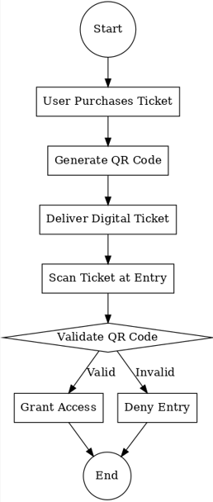
Figure 1: Activity Diagram

3.4 User Requirements
User requirements are the documented expectations and needs that a system must fulfill. Sommerville (2019) defines them as the services the system should provide and the constraints under which it must operate. Requirements are classified into functional and non-functional.

3.4.1 Functional Requirements
These specify what the system should do (Pohl & Rupp, 2021).
- Generate digital tickets with unique QR codes.
- Allow online ticket purchase.
- Validate tickets via QR scanners.
- Provide dashboards for event organizers.
- Generate automated reports (sales, attendance, revenue).

3.4.2 Non-Functional Requirements
These define the system’s quality attributes and constraints (Wiegers & Beatty, 2020).
- Performance: The system must validate tickets within 2 seconds.
- Security: Prevent ticket duplication and unauthorized reselling.
- Usability: Simple and intuitive interface for both organizers and attendees.
- Scalability: Support thousands of concurrent users.
- Reliability: 99% uptime during events.

3.5 Hardware Requirements
Table 5: Hardware Requirements
Item | Specification | Quantity | Available | Comment
Server | 8GB RAM, Intel 3.2GHz, 1TB HDD | 1 | No | To be purchased
Router | 2 Mbps and above | 1 | Yes | Already available
QR Scanner | Portable handheld QR code scanners | 2 | No | To be purchased
Laptop | Core i5, 8GB RAM, 500GB HDD | 1 | Yes | Already Available
Printer | HP LaserJet or equivalent | 1 | No | To be purchased
The hardware requirements ensure smooth hosting, ticket validation, and reporting. The server hosts the application, laptops are for development and management, while QR scanners speed up entry validation.

3.6 Software Requirements
Table 6: Software Requirements
Item | Specification | Quantity | Available
Operating System | Windows 10 / Linux | 1 | Yes
Web Framework | Laravel (PHP framework) | 1 | Yes
Database | MySQL | 1 | Yes
Localhost Server | XAMPP | 1 | Yes
Browser | Google Chrome, Mozilla | 1 | Yes
QR Code Library | PHP QR Code API | 1 | No
These software tools support the development, testing, and deployment of the ticketing system. Laravel ensures secure and structured development, while MySQL provides robust data storage.

3.7 System Models

3.7.1 Data Flow Diagram (DFD) / UML
A Data Flow Diagram is a graphical representation that illustrates how data flows within a system (Dennis, Wixom, & Roth, 2019). For the ticketing system, the DFD shows how data moves from ticket purchase to validation and reporting.

Level0 DFD:
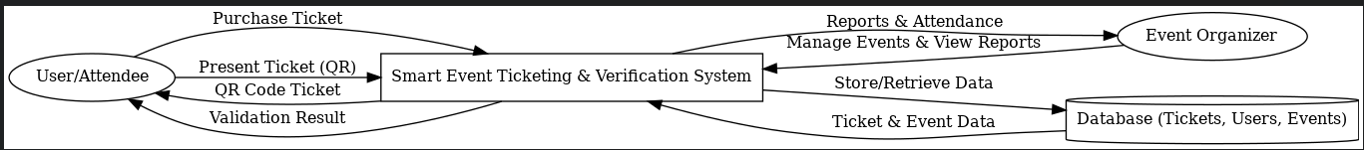
Figure 2: Level 0 DFD

3.7.2 Flow Chart
A flowchart is a graphical diagram that represents the sequence of operations in a process (Rajasekaran & Vijayalakshmi, 2020). It helps visualize ticket purchase and validation steps.
Diagram:
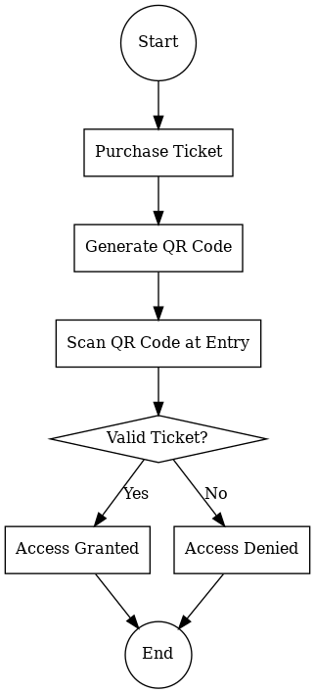
Figure 3: Flowchart

3.7.3 Entity Relationship Diagram (ERD) / Class Diagram
An ERD shows the relationships between entities in a database (Harrington, 2019). For this project, the ERD includes entities like User, Ticket, Event, and Payment, Organizer.
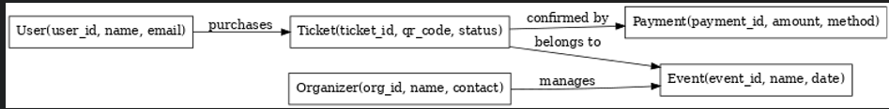
Figure 4: ERD

3.7.4 Data Dictionary
A data dictionary is a repository containing details about database fields, data types, and constraints (Coronel & Morris, 2020).
Table 7: Data Dictionary
Field Name | Data Type | Size | Description
Ticket_ID | INT | 10 | Unique identifier for each ticket
User_ID | INT | 10 | Unique identifier for each user
Event_ID | INT | 10 | Unique identifier for event
QR_Code | VARCHAR | 255 | Stores generated QR code string
PurchaseDate | DATE | - | Date of ticket purchase

3.8 Conclusion
This chapter detailed the research methodology and philosophy guiding the system’s development. Various data collection methods, questionnaires, interviews, and observations, provided user-centred insights. The analysis of user requirements defined both functional and non-functional needs, while system models illustrated workflows and relationships. Hardware and software requirements were identified to ensure feasibility. These findings lay the foundation for system design and implementation discussed in the next chapter.

CHAPTER 4: SYSTEM DESIGN

4.1 Introduction
System design is the process of defining the architecture, components, interfaces, and data for a system to satisfy specified requirements. According to Pressman (2010), system design translates user requirements into a blueprint for building the system. In the context of our Smart Event Ticketing & Verification System, system design ensures that the ticketing processes, QR validation, and reporting mechanisms are structured for efficiency, usability, and security.

4.2 Design Methodology
Design methodology refers to the structured approach used in developing the system. Kendall & Kendall (2011) define it as a framework that provides guidelines for analysis and design tasks.
For this project, we used the Structured System Design Methodology (SSDM), which emphasizes the use of diagrams such as DFDs, flowcharts, and ERDs to provide a clear visualization of processes and data movement. This methodology ensures that both technical and non-technical stakeholders understand the system’s design.

4.3 Physical Design
Physical design describes how the system will be implemented in terms of hardware, software, and network infrastructure.
- Hardware: Standard computers, barcode/QR scanners, and mobile devices.
- Software: Web application built with PHP/Laravel (backend), MySQL (database), and a user-friendly front-end (HTML, CSS, JavaScript).
- Network: Client-server architecture where users interact with the system over a secure internet connection.
This design ensures smooth ticket purchasing, QR validation at entry points, and real-time reporting.

4.4 Input Design
Input design defines how data enters the system. According to Galitz (2007), good input design ensures data accuracy, reduces redundancy, and enhances user satisfaction.
For our system, inputs include:
- Ticket purchase details (event, seat type; payment is simulated, so no payment method is captured in the current version).
- User credentials (registration/login).
- QR code scans at entry gates.
These inputs are designed with validation checks to minimize errors (e.g., checking if ticket ID exists before generating a QR code).
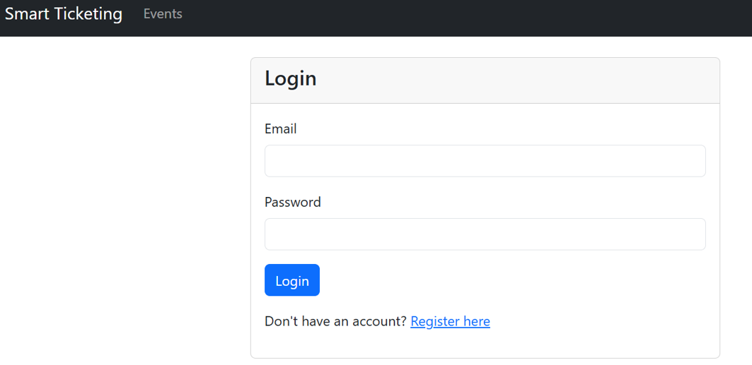
Figure 5: Input Design 1
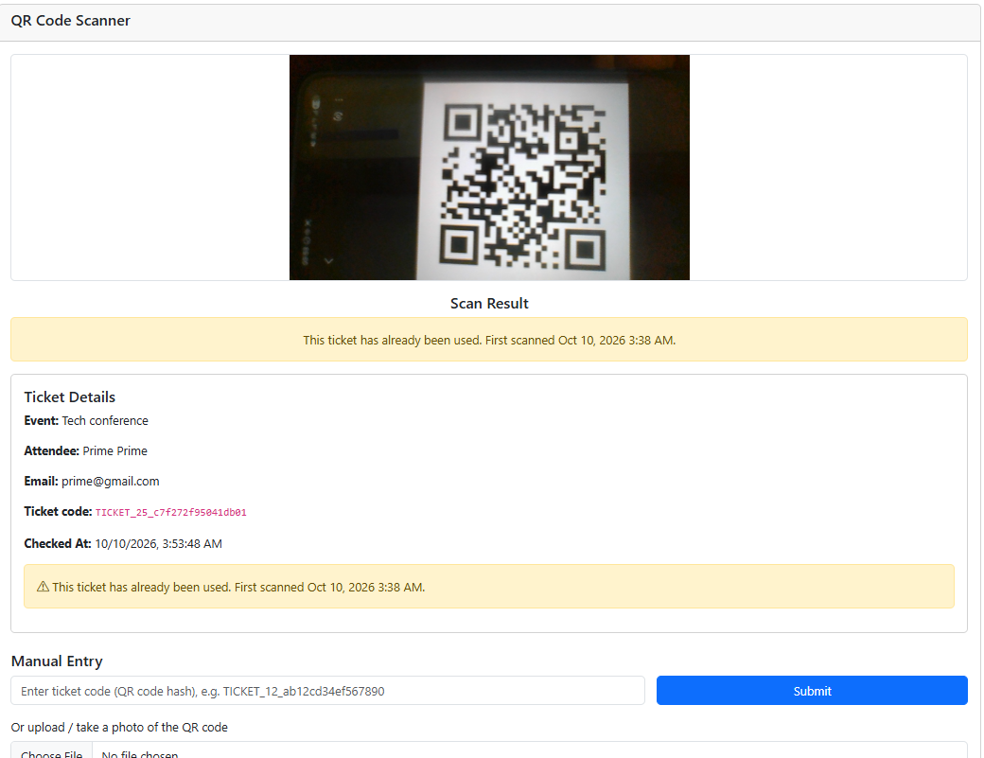
Figure 6: Input Design 2

4.5 Process Design
Process design involves modelling the sequence of operations and logic of the system.

Context Level Diagram
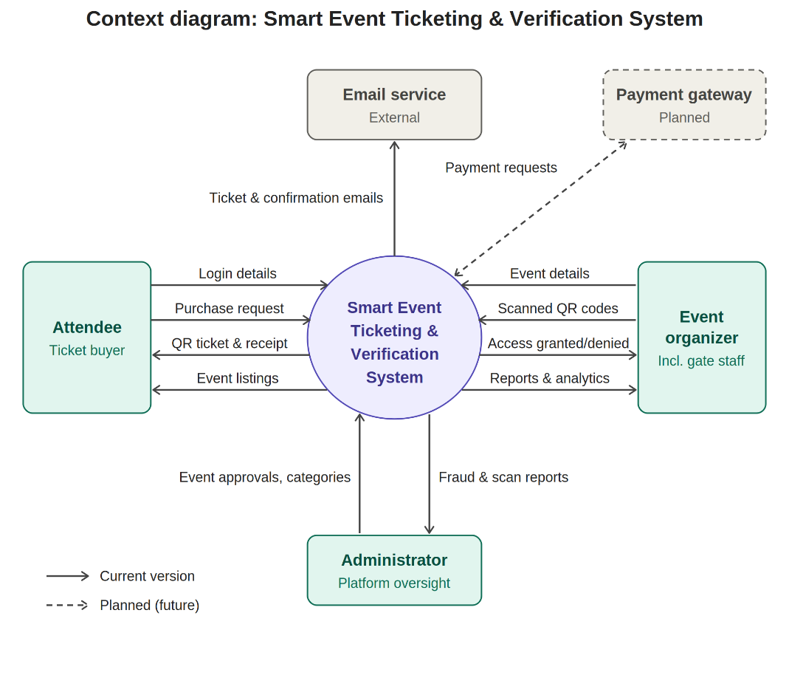

4.5.1 Data Flow Diagrams (DFD) / UML
A Data Flow Diagram (DFD) shows the flow of data between processes, external entities, and data stores. According to Yourdon (1989), a DFD is a graphical tool used to describe and analyze data movement in a system.
- In Chapter 3, the Level 0 DFD already illustrated how users, organizers, and the database interact.
- At Level 1, processes such as “Ticket Purchase,” “QR Code Generation,” and “Validation” are broken down in detail.
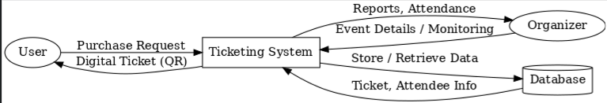
Figure 7: Level1 DFD

4.5.2 Flowcharts
A Flowchart is a diagram that uses symbols to represent the sequence of operations. As defined by Dennis & Wixom (2012), flowcharts are used to model processes and show decision paths in a structured manner.
- Flowchart below illustrated the steps from ticket purchase → QR code generation → scanning → validation decision → access granted/denied.
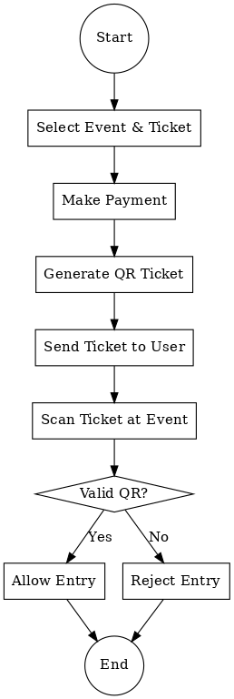
Figure 8: ticket purchase flowchart

4.5.3 Pseudocode / Structured English
Pseudocode is a simplified, English-like representation of program logic. It helps bridge the gap between system design and coding.
Example (Ticket Validation Process):
IF QR Code Exists in Database THEN
IF Ticket is Active AND Event Date is Valid THEN
Grant Access
ELSE
Deny Access
ENDIF
ELSE
Display "Invalid Ticket"
ENDIF

4.6 Output Design
Output design specifies how system results are presented to users. Whitten et al. (2004) define it as the process of designing reports, screens, and documents that provide useful information to end users.
Outputs in our system include:
- Digital QR tickets emailed to users.
- On-screen messages (“Access Granted” / “Access Denied”).
- Event attendance and sales reports for organizers.
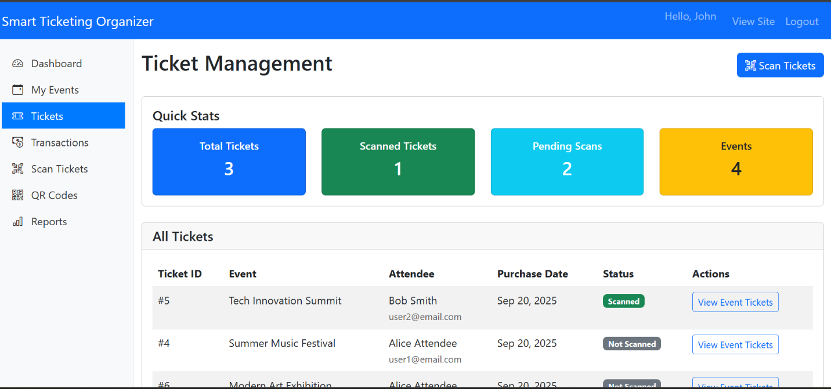
Figure 9: Output design 1

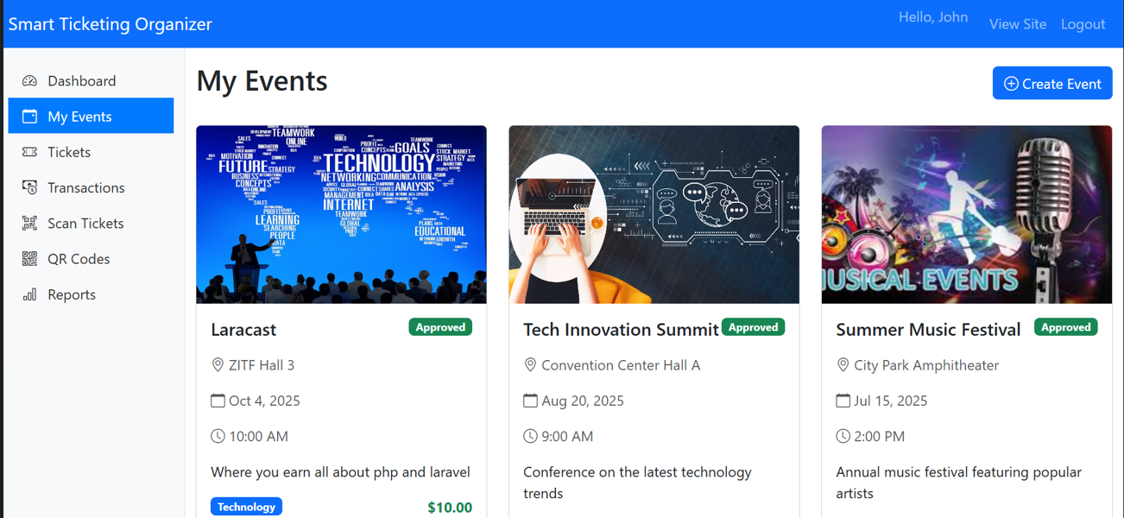
Figure 10: Output design 2
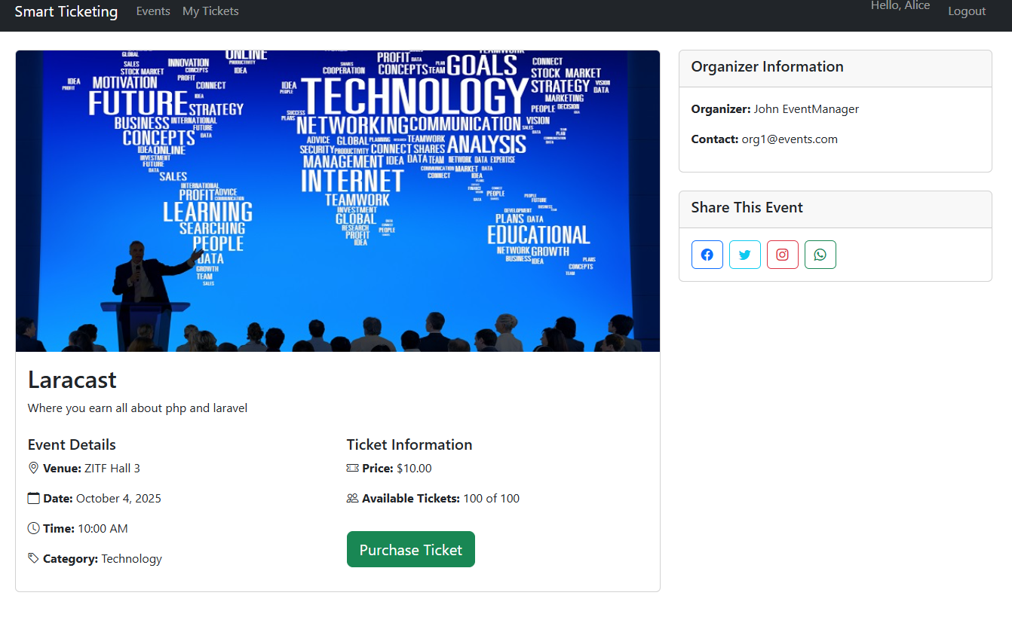
Figure 11: Output design 3

4.7 Dialogue Design
Dialogue design describes the interaction between users and the system. It ensures smooth communication through intuitive interfaces. Our system uses:
- Web-based forms for registration and ticket purchases.
- Mobile-friendly dashboards for organizers.
- Real-time scanner feedback at entry gates.

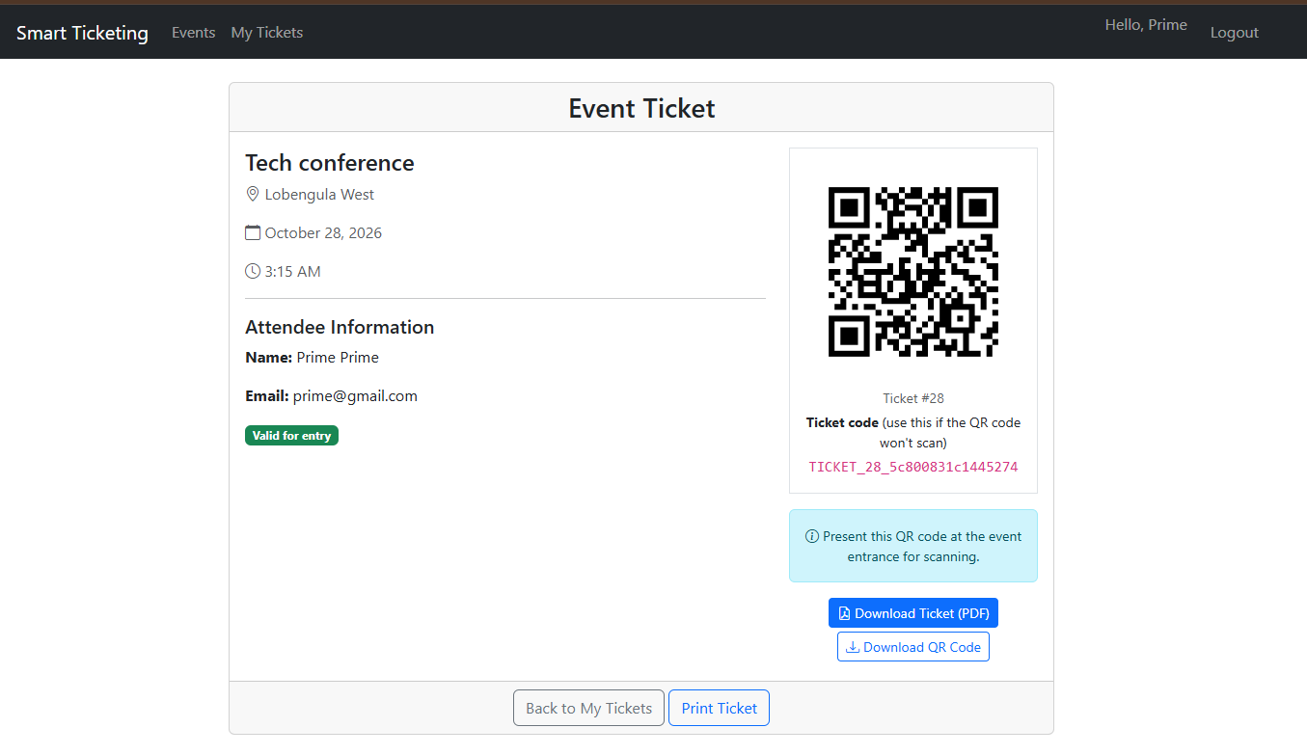
Figure 12: Dialogue design

4.8 Control and Security Design
Security is crucial to prevent fraud and unauthorized access.
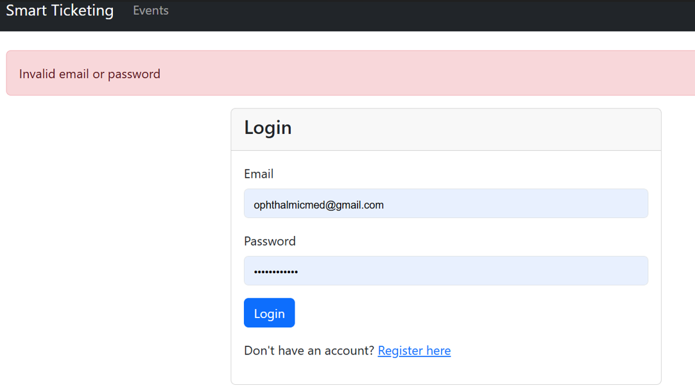
Figure 13: Control and Security Design

4.8.1 Input Controls
- Validation checks (e.g., mandatory fields, correct email format).
- Captcha for bot prevention.
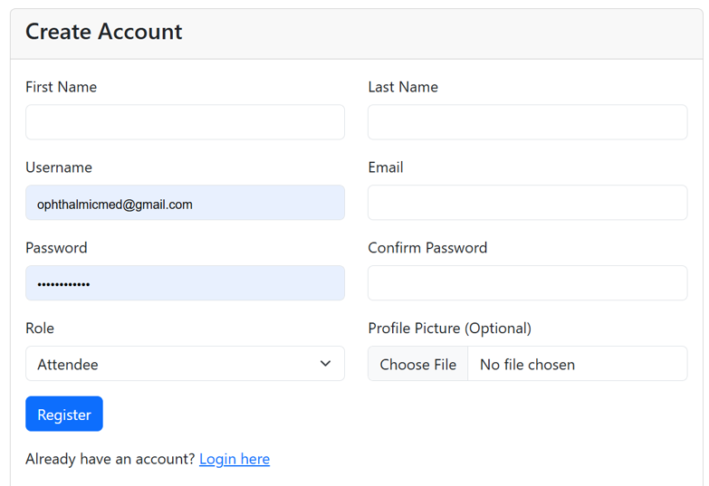
Figure 14: Input Controls1

Figure 15: Input Controls2

4.8.2 Process Controls
- Automatic QR code generation with encryption.
- Ticket status updated after validation.

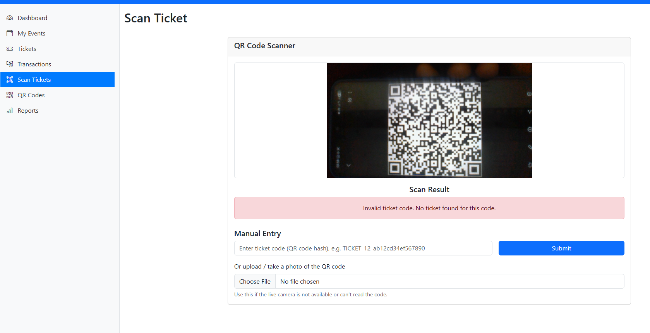
Figure 16: Process Controls

4.8.3 Output Controls
- Reports only accessible to authenticated organizers.
- Confirmation emails sent after successful ticket purchase.
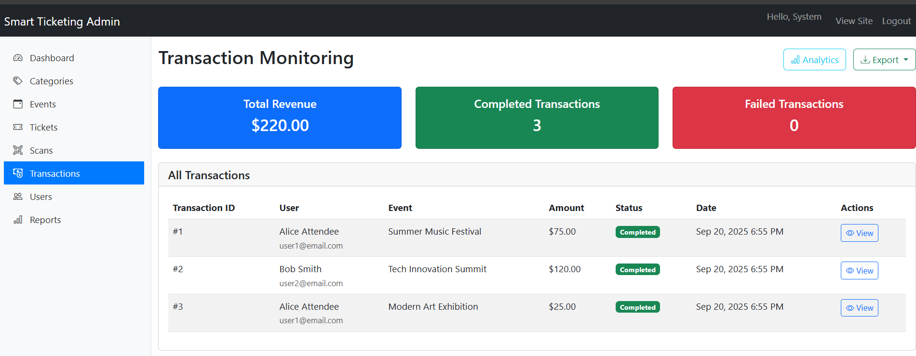
Figure 17: Output Controls

4.8.4 Database Controls
- Role-based access (admin, organizer, user).
- Backup and recovery strategies.

4.8.5 Physical Security
- Secure servers with restricted physical access.
- Surveillance at event entry points.

4.8.6 Logical Security
- User authentication via passwords.
- Encrypted QR codes and a payment module that is simulated in the current version (a secure payment gateway is planned for future integration).
Figure 18: Logical Security

4.9 Database Design

4.9.1 Database Model Used
The system uses a Relational Database Model (RDBMS), as defined by Codd (1970), where data is stored in related tables.

4.9.2 Database Tables
Main tables below:
Table 8: Database categories
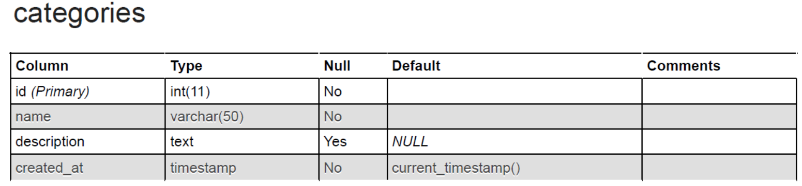
Table 9: Database Events
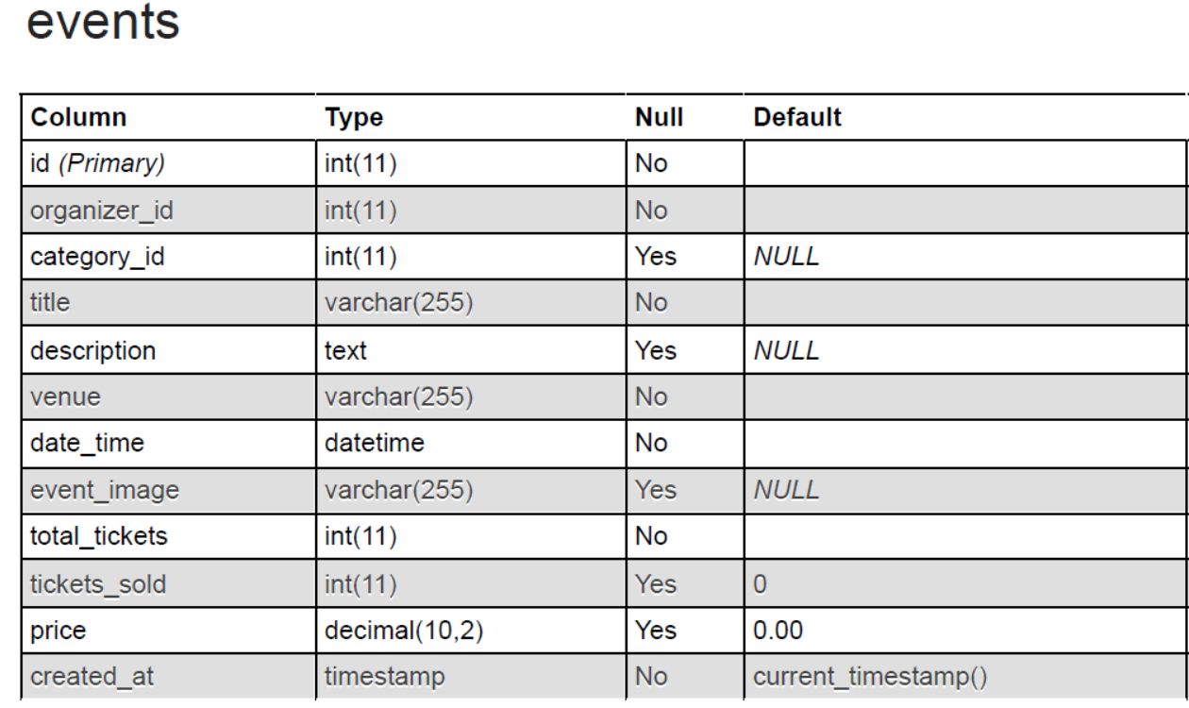
Table 10: Database Tickets
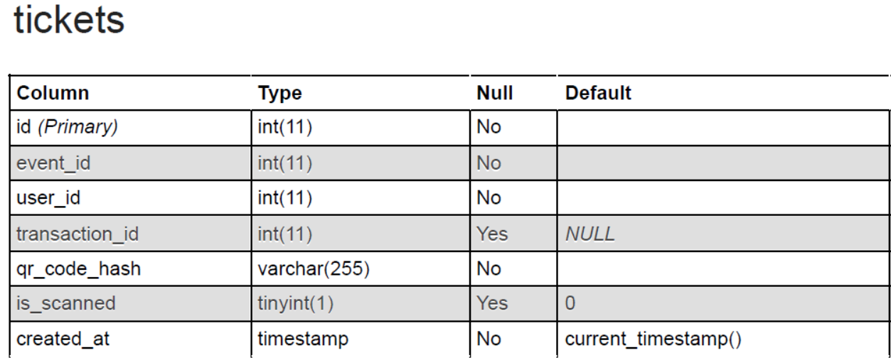
Table 11: Database Transactions
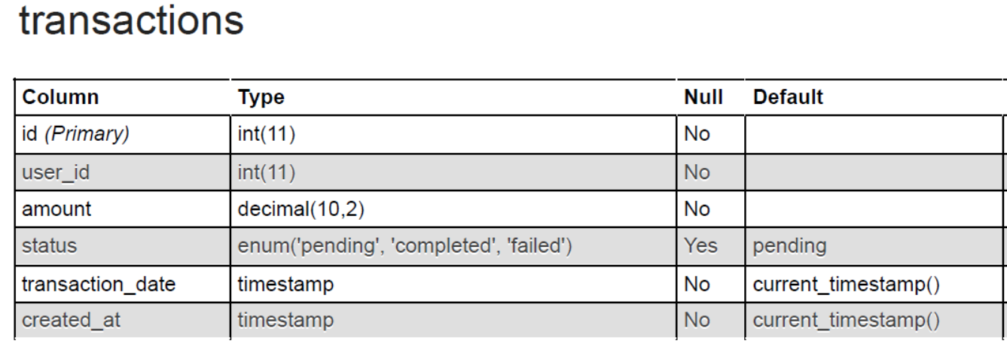
Table 12: Database Users
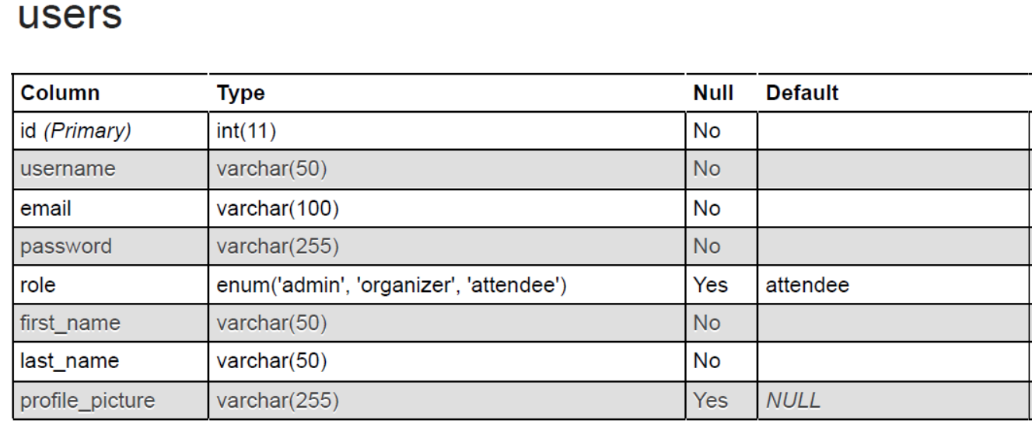

4.9.3 Normalization
Normalization minimizes redundancy and ensures data integrity. According to Date (2003), normalization organizes data into tables that reduce anomalies in insertion, update, and deletion.
- Tables were normalized to 3rd Normal Form (3NF).

4.9.4 Data Dictionary
Defines each field, data type, constraints, and purpose for all collections. This ensures developers can implement and maintain the database reliably.
Table 13: Data Dictionary
Field | Type | Description
TicketID | INT (PK) | Unique ticket identifier
EventID | INT (FK) | Links to Events table
QRCode | VARCHAR | Unique QR code string
Status | VARCHAR | (Active, Used, Expired)

4.9.5 Entity Relationship Diagram (ERD)
An ERD illustrates relationships between entities.
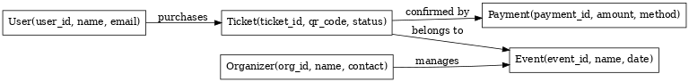
Figure 19: ERD

4.10 Conclusion
This chapter detailed the design of the Smart Event Ticketing & Verification System. Through structured methodology, process modelling (DFDs, flowcharts, pseudocode), input/output design, and robust security controls, the system was designed to ensure reliability, efficiency, and user-friendliness. The database design further supports scalability and data integrity, laying a strong foundation for implementation.

CHAPTER 5: CODING

Routes
<?php
// Calculate base URL
$baseDir = str_replace('\\', '/', dirname($_SERVER['SCRIPT_NAME']));
$baseUrl = rtrim($baseDir, '/');
define('BASE_URL', $baseUrl === '/' ? '' : $baseUrl);
if (session_status() === PHP_SESSION_NONE) {
session_start();
}
// Autoloader
require_once __DIR__ . '/autoloader.php';
use app\core\Router; // Fix capitalization here
// Calculate request path
$request_uri = $_SERVER['REQUEST_URI'];
$script_name = $_SERVER['SCRIPT_NAME'];
// Remove script path from request URI
if (strpos($request_uri, $script_name) === 0) {
$request_uri = substr($request_uri, strlen($script_name));
}
// Remove query string
$request_uri = explode('?', $request_uri, 2)[0];
$url = trim($request_uri, '/');
// Initialize router
$router = new Router(); // Fix capitalization here

// ============= Authentication =============
$router->get('', 'AuthController@redirectToLogin');
$router->get('login', 'AuthController@login');
$router->post('login', 'AuthController@login');
$router->get('register', 'AuthController@register');
$router->post('register', 'AuthController@register');
$router->get('logout', 'AuthController@logout');
// ============= Events =============
$router->get('events', 'EventController@index');
$router->get('events/create', 'EventController@create');
$router->post('events/store', 'EventController@store');
$router->get('events/{id}', 'EventController@show');
// ============= Tickets =============
$router->get('tickets', 'TicketController@index');
$router->get('tickets/{id}', 'TicketController@show');
$router->get('tickets/purchase/{eventId}', 'TicketController@purchase');
$router->get('tickets/validate/{qrCodeHash}', 'TicketController@validate');
// ============= Organizer Routes =============
$router->get('organizer/dashboard', 'organizer\DashboardController@index');
// ============= Organizer Event Routes =============
$router->get('organizer/events', 'organizer\EventController@index');
$router->get('organizer/events/create', 'organizer\EventController@create');
$router->post('organizer/events/store', 'organizer\EventController@store');
$router->get('organizer/events/edit/{id}', 'organizer\EventController@edit');
$router->post('organizer/events/update/{id}', 'organizer\EventController@update');
$router->post('organizer/events/delete/{id}', 'organizer\EventController@delete');
$router->get('organizer/events/view/{id}', 'organizer\EventController@view');
// ============= Organizer Ticket Routes =============
$router->get('organizer/tickets', 'organizer\TicketController@index');
$router->get('organizer/tickets/event/{id}', 'organizer\TicketController@view');
$router->get('organizer/tickets/scan/{id}', 'organizer\TicketController@scan');
// ============= Organizer Transaction Routes =============
$router->get('organizer/transactions', 'organizer\TransactionController@index');
$router->get('organizer/transactions/event/{id}', 'organizer\TransactionController@view');
// ============= Organizer Scan Routes =============
$router->get('organizer/scans', 'organizer\ScanController@index');
$router->get('organizer/scans/scan', 'organizer\ScanController@scan');
$router->post('organizer/scans/process', 'organizer\ScanController@processScan');
$router->get('organizer/scans/history', 'organizer\ScanController@history');
$router->get('organizer/scans/history/{id}', 'organizer\ScanController@history');

// ============= Organizer Reports Routes =============
$router->get('organizer/reports', 'organizer\ReportsController@index');
$router->get('organizer/reports/sales', 'organizer\ReportsController@sales');
$router->get('organizer/reports/attendance', 'organizer\ReportsController@attendance');
$router->get('organizer/reports/attendance/{id}', 'organizer\ReportsController@attendance');
$router->get('organizer/reports/event/{id}', 'organizer\ReportsController@event');
$router->get('organizer/reports/export/{type}', 'organizer\ReportsController@export');
$router->get('organizer/reports/export/{type}/{id}', 'organizer\ReportsController@export');

// ============= Organizer Scanner Routes =============
$router->get('organizer/scanner', 'organizer\ScannerController@index');
$router->get('organizer/scanner/scan', 'organizer\ScannerController@scan');
$router->post('organizer/scanner/process', 'organizer\ScannerController@processScan');
$router->get('organizer/scanner/result', 'organizer\ScannerController@result');
$router->get('organizer/scanner/history', 'organizer\ScannerController@history');
$router->get('organizer/scanner/history/{ticketId}', 'organizer\ScannerController@history');
$router->get('organizer/scanner/download', 'organizer\ScannerController@download');

// ============= Admin Routes =============
$router->get('admin/dashboard', 'admin\DashboardController@index');
// ============= Admin Category Routes =============
$router->get('admin/categories', 'admin\CategoryController@index');
$router->get('admin/categories/create', 'admin\CategoryController@create');
$router->post('admin/categories/store', 'admin\CategoryController@store');
$router->get('admin/categories/edit/{id}', 'admin\CategoryController@edit');
$router->post('admin/categories/update/{id}', 'admin\CategoryController@update');
$router->post('admin/categories/delete/{id}', 'admin\CategoryController@delete');
// ============= Admin Event Routes =============
$router->get('admin/events', 'admin\EventController@index');
$router->get('admin/events/view/{id}', 'admin\EventController@view');
$router->get('admin/events/approve/{id}', 'admin\EventController@approve');
$router->get('admin/events/reject/{id}', 'admin\EventController@reject');
$router->get('admin/events/disable/{id}', 'admin\EventController@disable');
// ============= Admin Ticket Routes =============
$router->get('admin/tickets', 'admin\TicketController@index');
$router->get('admin/tickets/view/{id}', 'admin\TicketController@view');
$router->get('admin/tickets/check/{id}', 'admin\TicketController@checkFraud');
$router->get('admin/tickets/history/{id}', 'admin\TicketController@scanHistory');

// ============= Admin Scan Routes =============
$router->get('admin/scans', 'admin\ScanController@index');
$router->get('admin/scans/view/{id}', 'admin\ScanController@view');
$router->get('admin/scans/analytics', 'admin\ScanController@analytics');
$router->get('admin/scans/suspicious', 'admin\ScanController@suspicious');
$router->get('admin/scans/export', 'admin\ScanController@export');
$router->get('admin/scans/export/{type}', 'admin\ScanController@export');

Login
public function login() {
$error = '';
if ($_SERVER['REQUEST_METHOD'] === 'POST') {
$email = $_POST['email'] ?? '';
$password = $_POST['password'] ?? '';

$userModel = new User();
$user = $userModel->findByEmail($email);
if ($user && password_verify($password, $user['password'])) {
// Set user session
$_SESSION['user'] = [
'id' => $user['id'],
'username' => $user['username'],
'email' => $user['email'],
'role' => $user['role'],
'first_name' => $user['first_name'],
'last_name' => $user['last_name'],
'profile_picture' => $user['profile_picture']
];
// Redirect based on role
switch ($user['role']) {
case 'admin':
$this->redirect('admin/dashboard');
break;
case 'organizer':
$this->redirect('organizer/dashboard');
break;
default:
$this->redirect('events');
}
return;
} else {
$error = "Invalid email or password";
}
}
$this->render('auth/login', [
'error' => $error,
'title' => 'Login - Smart Ticketing'
]);
}

Register
public function register() {
$error = '';
$success = '';
if ($_SERVER['REQUEST_METHOD'] === 'POST') {
// Get form data
$username = $_POST['username'] ?? '';
$email = $_POST['email'] ?? '';
$password = $_POST['password'] ?? '';
$confirm_password = $_POST['confirm_password'] ?? '';
$role = $_POST['role'] ?? 'attendee';
$firstName = $_POST['first_name'] ?? '';
$lastName = $_POST['last_name'] ?? '';
// Validate passwords match
if ($password !== $confirm_password) {
$error = "Passwords do not match";
} else {
// Check if email already exists
$userModel = new User();
if ($userModel->emailExists($email)) {
$error = "Email already registered";
} else if ($userModel->usernameExists($username)) {
$error = "Username already taken";
} else {
// Handle file upload
$profilePicture = $this->handleProfilePicUpload();
// Create new user
if ($userModel->create($username, $email, $password, $role, $firstName, $lastName, $profilePicture)) {
$success = "Registration successful! You can now login.";
// Redirect to login after successful registration
$this->redirect('login');
} else {
$error = "Registration failed. Please try again.";
}
}
}
}

Logout
public function logout() {
// Unset all session variables
$_SESSION = [];
// Destroy the session
session_destroy();
// Redirect to login page
$this->redirect('login');
}

Update Event
public function updateEvent($id, $organizerId, $categoryId, $title, $description, $venue, $dateTime, $eventImage, $totalTickets, $price) {
$sql = "UPDATE events SET
category_id = :category_id,
title = :title,
description = :description,
venue = :venue,
date_time = :date_time,
total_tickets = :total_tickets,
price = :price";

if ($eventImage) {
$sql .= ", event_image = :event_image";
}

$sql .= " WHERE id = :id AND organizer_id = :organizer_id";

$stmt = $this->db->prepare($sql);

$stmt->bindParam(':category_id', $categoryId);
$stmt->bindParam(':title', $title);
$stmt->bindParam(':description', $description);
$stmt->bindParam(':venue', $venue);
$stmt->bindParam(':date_time', $dateTime);
$stmt->bindParam(':total_tickets', $totalTickets);
$stmt->bindParam(':price', $price);
$stmt->bindParam(':id', $id);
$stmt->bindParam(':organizer_id', $organizerId);

if ($eventImage) {
$stmt->bindParam(':event_image', $eventImage);
} }

Scan View
<div class="d-flex justify-content-between align-items-center mb-4">
<h2>Scan Ticket</h2>
<a href="<?= BASE_URL ?>/organizer/scanner" class="btn btn-outline-secondary">
<i class="bi bi-arrow-left"></i> Back to Scanner
</a>
</div>

<div class="row">
<div class="col-md-8">
<div class="card">
<div class="card-header">
<h5 class="card-title">QR Code Scanner</h5>
</div>
<div class="card-body">
<div id="scanner-container" class="text-center">
<div id="camera-permission" class="alert alert-info">
<i class="bi bi-camera"></i> Please allow camera access to use the scanner.
</div>
<div id="video-container">
<video id="qr-video" width="100%" height="300" class="border rounded" style="display: none;"></video>
</div>
<div id="camera-error" class="alert alert-warning mt-3" style="display: none;">
<i class="bi bi-camera-video-off"></i> Camera access denied or not available. Please use manual entry.
</div>
<div id="browser-error" class="alert alert-danger mt-3" style="display: none;">
<i class="bi bi-exclamation-triangle"></i> Your browser doesn't support camera access. Please use a modern browser or manual entry.
</div>
<div id="qr-result" class="mt-3" style="display: none;">
<h5>Scan Result</h5>
<div id="result-message" class="alert alert-info"></div>
<div id="ticket-details"></div>
</div>
</div>
<div class="mt-4">
<h5>Manual Entry</h5>
<form id="manual-scan-form" class="row g-3">
<div class="col-md-8">
<input type="text" class="form-control" id="manual-qr-code" placeholder="Enter QR code hash" required>
</div>
<div class="col-md-4">
<button type="submit" class="btn btn-primary w-100">Submit</button>
</div>
</form>
</div>
</div>
</div>
</div>

CHAPTER 6: IMPLEMENTATION

6.1 Introduction
Implementation is the process of putting the designed and developed system into actual operation. According to Sommerville (2011), system implementation involves translating the developed software into a working solution that users can operate effectively. For the Smart Event Ticketing & Verification System, this stage covers installing the system, testing, training users, and evaluating overall effectiveness.

6.2 System Testing
Testing ensures the developed system meets user requirements and functions as expected. Myers (2004) defines testing as the process of executing a program with the intent of finding errors.

6.2.1 Testing Procedures (Verification and Validation)
- Verification: Ensures the system was built correctly according to design specifications (e.g., checking database structure, QR code generation).
- Validation: Ensures the system meets user needs (e.g., scanning tickets at the gate produces correct results).

6.2.2 Testing Process (Methodologies)
We applied multiple methodologies:
- Unit Testing: Tested individual modules such as ticket purchase, QR code generation, and scanning.
- Integration Testing: Verified that modules worked together (e.g., database updates after QR validation).
- System Testing: Ensured end-to-end processes functioned correctly.
- User Acceptance Testing (UAT): Allowed real users (event organizers and attendees) to test the system before deployment.

6.2.3 Test Data
Test data was both valid and invalid to check how the system handled expected and unexpected inputs.
- Valid: Correct user credentials, a simulated payment recorded as completed, legitimate QR codes.
- Invalid: Wrong ticket IDs, expired tickets. Payment references were not tested because payment is simulated.

6.2.4 Test Results
Results showed that:
- Valid QR codes granted access successfully.
- Invalid/expired tickets were denied entry with appropriate error messages.
- Reports generated matched actual event attendance.
- Minor issues (e.g., duplicate seat booking) were fixed during debugging.

6.3 System Conversion
System conversion is the process of moving from the old system (manual ticketing) to the new system (smart ticketing). Laudon & Laudon (2012) describe it as the process of changing from the old information system to the new one.
For our project, we used a parallel conversion strategy, meaning the old system (manual ticketing) and new system (QR-based) ran simultaneously during initial deployment. This reduced risk and gave organizers confidence before fully switching.

6.4 User Training
Effective training is essential for system adoption. According to Davis (1989), user training enhances system acceptance and reduces resistance to change.
- Attendees: Guided through the ticket purchase and QR scanning process.
- Organizers: Trained to manage events, generate reports, and handle errors.
- Support Staff: Trained to troubleshoot scanning devices and internet issues.
Training methods included demonstrations, user manuals, and on-site support.

6.5 System Evaluation
Evaluation helps measure whether the system achieved its objectives.

6.5.1 Strengths
- Quick, paperless ticketing using QR codes.
- Enhanced security through encrypted tickets.
- Real-time attendance tracking and reporting.
- Improved user convenience (online purchase).

6.5.2 Weaknesses
- Dependence on internet connectivity for real-time validation.
- Requires training for non-technical users.
- Initial setup costs for scanners and servers.
- Payment is simulated in the current version; no real money is collected (see the note below).
Note on simulated payment: In the current version of the system, ticket payment is simulated. When a logged-in attendee selects Purchase Ticket, the system records a transaction for the event price with a status of completed and immediately issues the ticket together with its unique QR code. No money is actually collected and no mobile money, card or cash payment method is captured or stored. All other processes like registration, ticket purchase, QR code generation, scanning, validation and reporting, work fully. Only the collection of real money is simulated.
Reason for simulating payment: Real payment gateways such as EcoCash, Paynow and PayPal can only be used by a registered merchant. A merchant account is an account opened with a payment provider (a bank or a mobile money operator) that allows a business to receive customer payments online. Once the account is approved, the provider issues the credentials (for example an integration ID and key) that the system must use to process live transactions. To open a merchant account, the provider normally requires proof of business registration, such as a registered company or trading name, together with tax details, a business bank account and identification of the owners. Approval can take time and may involve fees. This system was developed as a student project for the National Diploma in Information Technology and is not yet operated by a registered business, so these requirements could not be met. Simulating payment therefore made it possible to build, demonstrate and test the complete ticketing workflow without handling real money or customers’ financial data. Integration of a live payment gateway is listed under Future Plans.

6.5.3 Future Plans
- Mobile application development for easier access.
- Integration with multiple payment gateways (e.g., PayPal, EcoCash) to replace the current simulated payment, once the required merchant accounts have been obtained.
- Offline QR scanning support to mitigate connectivity issues.
- AI-based analytics for predicting ticket sales and attendance trends.

6.6 Conclusion
This chapter detailed the implementation process of the Smart Event Ticketing & Verification System, covering testing, conversion, training, and evaluation. The system was successfully deployed with positive results in ticket validation, security, and reporting. Although challenges such as connectivity and training were noted, the strengths outweighed the weaknesses, making the system a practical and scalable solution for event management.

CHAPTER 7: FUTURE PLANS
Overview
The Smart Ticketing and Verification System (STVS) is designed to modernize event management by streamlining ticket sales, automating validation using QR codes, and enhancing security against fraud. While the current version effectively manages online ticket purchases, attendee verification, and reporting, future plans aim to ensure the system evolves with technological advancements and the growing demands of large-scale event operations.
These future plans focus on system scalability, improved user experience, data security, and integration with emerging event technologies. The overarching goal is to transform STVS into an intelligent, fully automated event management solution that supports organizers, vendors, and attendees through innovation, reliability, and seamless user interaction.

7.1 System Enhancements
The current Smart Ticketing and Verification System supports event registration, ticket purchasing, QR code generation, and attendee validation. However, several enhancements can significantly expand its efficiency and impact through:
- Predictive Analytics and Smart Insights
  - By analyzing ticket sales trends, attendance data, and event demographics, STVS can predict peak demand periods and optimize ticket pricing or seating arrangements.
  - Predictive analytics can alert organizers of potential overcrowding or low turnout events, improving planning and resource allocation.
  - Real-time dashboards will allow organizers to visualize live sales, gate entries, and attendee engagement metrics.
- Integration with External Event Platforms
  - Integration with third-party services such as payment gateways, social media platforms, and CRM tools will enhance data flow and marketing capabilities.
  - APIs can enable synchronization with venue management systems, security check-in software, and government licensing platforms for large-scale events.
  - Linking with transportation or accommodation platforms can help provide complete event packages to attendees.
- User Interface (UI) and Experience (UX) Improvements
  - Future versions will include a responsive mobile-first design for better accessibility on smartphones and tablets.
  - A modernized dashboard with color-coded analytics, ticket status indicators, and notification panels will improve user interaction.
  - Features such as dark mode, accessibility options (e.g., screen reader support), and customizable widgets will improve inclusivity and usability.
- Performance and Scalability
  - As event sizes and ticket volumes increase, STVS must handle higher concurrent transactions efficiently.
  - Implementing database optimization, caching, and distributed servers will enhance performance.
  - Continuous load testing will ensure stability and responsiveness during high-demand periods, such as major concerts or sporting events.

7.2 Security Enhancements
Since STVS manages sensitive payment and user data, maintaining a strong security framework is critical.
- Regular Security Audits
  - Conduct periodic penetration tests and code reviews to identify vulnerabilities in authentication, payment, and API endpoints.
  - Ensure compliance with global data protection standards such as GDPR, PCI DSS, and local cybersecurity regulations.
- Multi-Factor Authentication (MFA)
  - Introduce MFA for admin and event organizer accounts to prevent unauthorized access.
  - Advanced authentication options, such as one-time passwords (OTPs) and biometric verification, can further strengthen system integrity.
- Data Encryption and Integrity
  - Encrypt all user and payment data both in transit (via SSL/TLS) and at rest within secure databases.
  - Maintain comprehensive audit trails to track all critical operations and user activities.

7.3 User Training and Support
Effective system adoption relies on user understanding and continuous support.
- Training Programs
  - Conduct workshops and webinars for event organizers, vendors, and ticketing agents to master core functionalities.
  - Provide simulation environments for organizers to practice ticket setup, payment configuration, and gate validation before live events.
- Knowledge Base and Documentation
  - Develop a built-in help center featuring manuals, FAQs, and step-by-step guides.
  - Offer video tutorials demonstrating ticket creation, report generation, and real-time monitoring tools.
  - Create a support forum where users can share experiences, raise issues, and suggest improvements.
- Continuous Onboarding
  - Introduce interactive onboarding modules for new event organizers.
  - Role-based tutorials will ensure users only learn the features relevant to their responsibilities.
  - Offer certification programs for verified organizers and system administrators.

7.4 Regular User Feedback Sessions

Continuous engagement with end-users ensures STVS evolves based on real-world needs.
- Conduct quarterly feedback surveys with event organizers, gate attendants, and attendees to assess performance and usability.
- Collect metrics such as check-in speed, system downtime, and user satisfaction rates to guide enhancements.
- Implement a “Feedback-to-Action” mechanism where user suggestions are logged, prioritized, and incorporated into future updates.
- Host beta-testing programs for major updates, allowing key users to test new features before official release.

7.5 Long-Term Vision

The long-term direction of STVS focuses on technological innovation, scalability, and operational intelligence.
- Integration with Emerging Technologies
  - Artificial Intelligence (AI): Predict demand, automate ticket pricing, and detect potential fraudulent activities.
  - Machine Learning (ML): Analyze user behavior and optimize marketing campaigns based on ticket purchase patterns.
  - IoT Integration: Use smart scanners and NFC devices at venues for faster, contactless validation.
- Scalability and Expansion
  - Extend STVS to support multi-event and multi-organizer operations on a cloud-based architecture.
  - Enable global access with multilingual support and regional currency integration.
  - Introduce white-label licensing options for organizations to customize and rebrand the platform.
- Continuous Improvement
  - Adopt Agile and DevOps methodologies for continuous system monitoring, feature deployment, and bug resolution.
  - Track KPIs such as response time, uptime, and transaction success rate to ensure top performance.
  - Maintain strategic partnerships with event management firms and cybersecurity experts for sustained innovation.

7.6 Conclusion

The future development of the Smart Ticketing and Verification System aims to advance the event industry by merging automation, intelligence, and security. Through predictive analytics, blockchain verification, and mobile-first design, STVS will evolve into a fully integrated event ecosystem supporting seamless user experiences from purchase to entry.

Regular security upgrades, continuous training, and an active feedback loop will ensure that STVS remains reliable, scalable, and relevant. Ultimately, these enhancements will empower event organizers, improve attendee satisfaction, and strengthen trust across digital ticketing platforms worldwide.

REFERENCES
- Ilhan, A. E. (2025). Design approaches to improve user experience. ScienceDirect. https://doi.org/10.1016/j.dss.2025.04.001
- Reinhartz-Berger, I. (2025). A data-driven retrospective analysis of studies published at the Exploring Modeling Methods for Systems Analysis and Development (EMMSAD) working conference from 2005 to 2024. Software and Systems Modeling. https://doi.org/10.1007/s10270-025-01302-4
- Feulner, S., Sedlmeir, J., & Urbach, N. (2022). Exploring the use of self-sovereign identity for event ticketing systems. ResearchGate. https://doi.org/10.13140/RG.2.2.36457.22883
- Huang, P.-C., Chang, C.-H., Li, Y., & Liu, Y. (2019). The proposed data hiding technology with QR code, applied in the case of e-Ticket system. ResearchGate. https://doi.org/10.13140/RG.2.2.36457.22883
- Feulner, S., Sedlmeir, J., & Urbach, N. (2022). Exploring the use of self-sovereign identity for event ticketing systems. ResearchGate. https://doi.org/10.13140/RG.2.2.36457.22883
- Huang, P.-C., Chang, C.-H., Li, Y., & Liu, Y. (2019). The proposed data hiding technology with QR code, applied in the case of e-Ticket system. ResearchGate. https://doi.org/10.13140/RG.2.2.36457.22883
- Feulner, S., Sedlmeir, J., & Urbach, N. (2022). Exploring the use of self-sovereign identity for event ticketing systems. ResearchGate. https://doi.org/10.13140/RG.2.2.36457.22883
- Feulner, S., Sedlmeir, J., & Urbach, N. (2022). Exploring the use of self-sovereign identity for event ticketing systems. ResearchGate. https://doi.org/10.13140/RG.2.2.36457.22883
- Zhang, Y., Fan, W., Chen, H., & Wu, Z. (2007). The architecture of an e-Ticket system. ResearchGate. https://doi.org/10.13140/RG.2.2.36457.22883

APPENDIX A: INTERVIEW GUIDE
Purpose: To gather qualitative data from event organizers, staff, and attendees regarding challenges with current ticketing processes and expectations for a QR-based system.
Interview Questions:
- Can you describe the current ticketing process at your events?
- What are the main challenges you face with paper-based ticketing?
- Have you experienced ticket fraud or duplication issues? If yes, how frequent?
- How do you track attendance and revenue from events?
- What features would you like to see in a digital ticketing system?
- Would a QR-based ticketing system improve efficiency? Why or why not?
- How comfortable are you with using technology for ticketing purposes?
- Are there any concerns you foresee with implementing a QR code ticketing system?
Notes Section:
- Record responses carefully.
- Note observations on user attitudes toward technology.
- Follow up on unclear answers for deeper insights.

APPENDIX B: QUESTIONNAIRE
Purpose: To collect structured feedback from attendees regarding their experiences and expectations with ticketing systems.
Instructions: Respondents should answer all questions honestly. Tick (✔) or write your answer where applicable.
Demographics:
- Name (Optional): __________________Age: _______
- Gender: ☐ Male ☐ Female ☐ Other
Questions:
- How often do you attend events?
☐ Rarely ☐ Occasionally ☐ Frequently
- How do you usually purchase tickets?
☐ Manual/Paper ☐ Online ☐ Both
- Have you ever experienced delays during event entry?
☐ Yes ☐ No
- Have you experienced ticket fraud or duplication?
☐ Yes ☐ No
- Would you prefer a QR-based ticketing system?
☐ Yes ☐ No
- How important is real-time event updates via digital platforms?
☐ Very Important ☐ Important ☐ Neutral ☐ Not Important
- Any suggestions to improve ticketing experience? ___________________________

APPENDIX C: OBSERVATION GUIDE
Purpose: To observe the ticketing and entry process at events to identify bottlenecks and inefficiencies.
Observation Checklist:
Activity | Observed Issue | Frequency | Notes/Comments
Ticket purchase | Delays at ticket counters | High/Medium/Low | ______________________
Queue management | Long waiting lines | High/Medium/Low | ______________________
Ticket verification | Errors or duplicate tickets | High/Medium/Low | ______________________
Staff handling of ticketing | Training or competence issues | High/Medium/Low | ______________________
Attendee satisfaction | Complaints or feedback | High/Medium/Low | ______________________
Guidelines for Observers:
- Record the time, number of attendees, and process delays.
- Note the interaction between staff and attendees.
- Identify repeated issues that may affect system design.

